**DAILY ONLINE ACTIVITIES SUMMARY**

|  |  |  |  |  |  |  |  |  |
| --- | --- | --- | --- | --- | --- | --- | --- | --- |
| **Date:** | **14/07/2020** | | | | | **Name:** | **Pratibha Shetti** | |
| **Sem & Sec** | **IV sem & B section** | | | | | **USN:** | **4AL18CS062** | |
| **Online Test Summary** | | | | | | | | |
| **Subject** | |  | | | | | | |
| **Max. Marks** | | **30** | | **Score** | | | **-** | |
| **Certification Course Summary** | | | | | | | | |
| **Course** | **Predictive modeling and analysis** | | | | | | | |
| **Certificate Provider** | | | **Greatlearning academy** | | **Duration** | | | **5.5hours** |
| **Coding Challenges** | | | | | | | | |
| **Problem Statement1:**  Write a Java Program to find the duplicate characters in a string.  — | | | | | | | | |
| **Status: Executed** | | | | | | | | |
| **Uploaded the report in Github** | | | | | **YES** | | | |
| **If yes Repository name** | | | | | <https://github.com/pratibhashetty-123/Lockdown-coding-for-python/blob/master/sortlist.py> | | | |
| **Uploaded the report in slack** | | | | | **YES** | | | |

Online Test Summary: No internals conducted today.

Online Certification Course Summary: In today’s session I have learnt about the Blockchain Examples where is the blockchain technology used and one of the company where the technology used is Walmart and many other companies but Walmart is the popular.

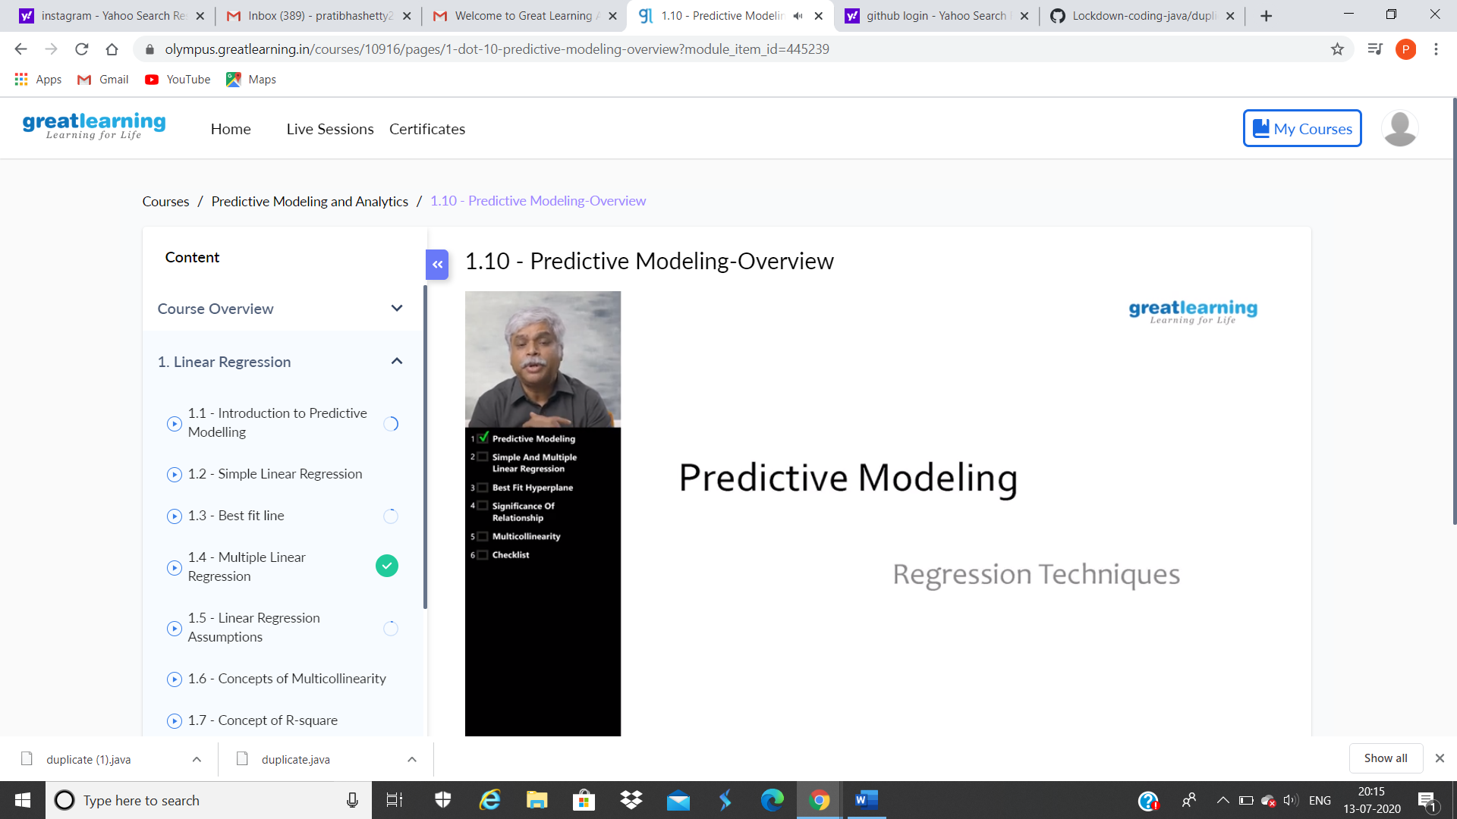

This is the snapshot of today’s session.

Online Coding Summary: : **Today I had received one program. The program is mentioned above in the coding challenges(pg.01). I have also uploaded it to my Github repository.**

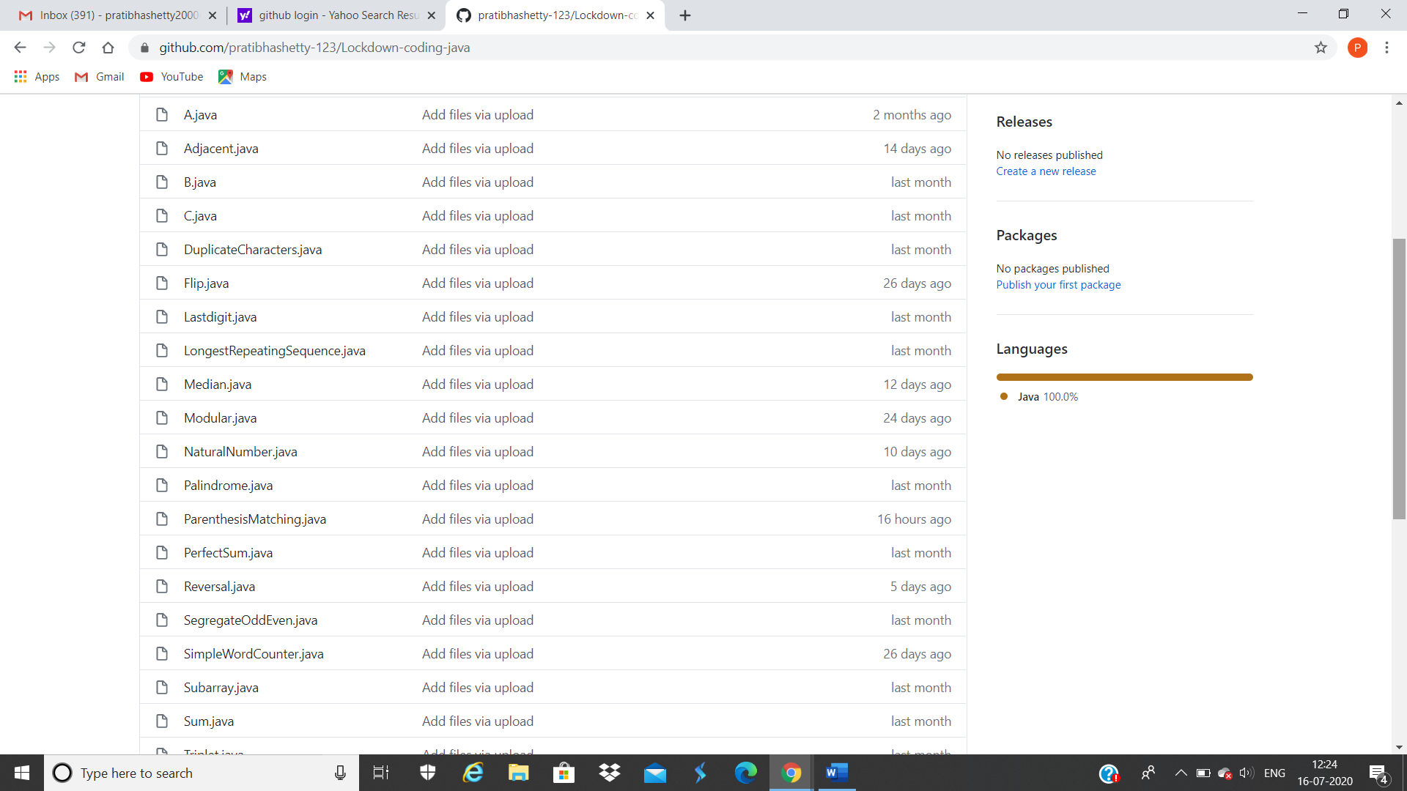

**This is the snapshot of my Github repository** were I have uploaded the code. File name is duplicat.java and ParenthesisMatching.java